Game Design Document

Fill up the following document

1. Write the title of your project.

Maze Game

1. What is the goal of the game?

Cross the Maze Without touching the Walls.

1. Write a brief story of your game.

Sophia loves to play maze games, where her mother helps her create actual mazes using cardboard pieces at home. Sophia has just embarked on a coding learning journey and she is eager to try her hand at creating a virtual game of maze.

Help Sophia build a such a game with a path that leads to a golden cup..

1. Which are the playing characters of this game?

* Playing characters are the ones who respond to the user based on the input from the user.
* Cars, monkeys, dinos, wizards, etc., are the playing characters in the game.

|  |  |  |
| --- | --- | --- |
| Number | Character Name | What can this character do? |
| 1 | Player(mouse) | Control by mouse |
| 2 |  |  |
| 3 |  |  |
| 4 |  |  |
| 5 |  |  |
| 6 |  |  |
| 7 |  |  |
| 8 |  |  |

1. Which are the Non-Playing Characters of this game?

* Non-Playing characters are the ones that don't have an action or behavior when the user interacts with the game.
* Hurdles, stones, bananas, coins, etc., are non-playing characters in the game.

|  |  |  |
| --- | --- | --- |
| Number | Character Name | What can this character do? |
| 1 |  |  |
| 2 |  |  |
| 3 |  |  |
| 4 |  |  |
| 5 |  |  |
| 6 |  |  |
| 7 |  |  |
| 8 |  |  |

Draw your imagination of this game. What does this game look like?

* Draw the game either on your computer or on paper.
* Add images of the game scenes to show each of the playing and non-playing characters at least once.

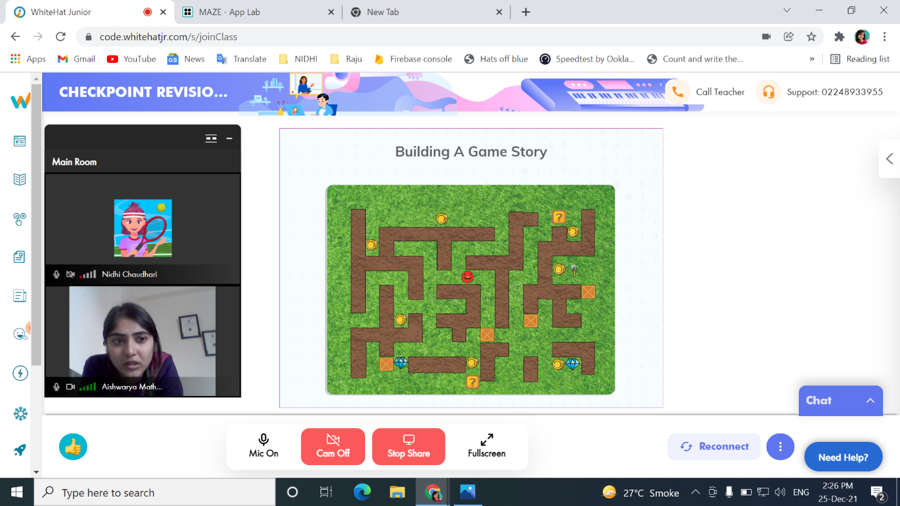

How do you plan to make your game engaging?

Player is not allowed to touch the wall , if the player touches the wall the game is over.player can choose two types of Maze.